Mini project Report on

**BUS BOOKING SYSTEM**

Submitted by

Mohit kamble: 574

Akshay Kalapgar: 573

Harsh Dobariya: 572

Guided by

Prof. **Anushree Deshmukh**



**DEPARTMENT OF INFORMATION TECHNOLOGY**

**UNIVERSITY OF MUMBAI NOVEMBER 2019**

***CERTIFICATE***

Date:

This is to certify that, the mini project work embodied in this report entitled, “***BUS BOOKING SYSTEM***” submitted by “***Mohit Kamble*** bearing Roll No. 574” , “***Akshay Kalapgar*** bearing Roll No. 573”, “***Harsh Dobariya*** bearing Roll No. 572” for the award of ***Third year in Bachelor Of Engineering (T.E.)*** degree in the subject of ***Information Technology***, is a work carried out by them under my guidance and supervision within the institute. The work described in this mini project report is carried out by the concerned students and has not been submitted for the award of any other degree of the University of Mumbai.

Further, it is certify that the students were regular during the academic year 2019-2020 and have worked under the guidance of concerned faculty until the submission of this mini project work at ***Rajiv Gandhi Institute of Technology, Mumbai***.

Prof. Anushree Deshmukh

**Mini Project Guide**

Dr. Sunil B. Wankhade Dr. Sanjay U. Bokade

**Head of Department Principal**

**CERTIFICATE OF APPROVAL**

## This mini project report entitled

Submitted by:

|  |  |
| --- | --- |
| **MOHIT KAMBLE** | **574** |
| **AKSHAY KALAPGAR** | **573** |
| **HARSH DOBARIYA** | **572** |

In partial fulfillment of the requirements of the degree of **Third year in Bachelor of Engineering** in **Information Technology** is approved.

# Internal Examiner

**External Examiner**

SEAL OF INSTITUTE

**Declaration**

I declare that this written submission represents my ideas in my own words and where others' ideas or words have been included, I have adequately cited and referenced the original sources. I also declare that I have adhered to all principles of academic hone sty and integrity and have not misrepresented or fabricated or falsified any idea/data/fact/source in my submission. I understand that any violation of the above will be cause for disciplinary action by the Institute and can also evoke penal action from the sources which have thus not been properly cited or from whom proper permission has not been taken when needed.

|  |  |  |
| --- | --- | --- |
| ROLL NO. | NAME | SIGNATURE |
| 574 | MOHIT KAMBLE |  |
| 573 | AKSHAY KALAPGAR |  |
| 572 | HARSH DOBARIYA |  |

Date: Place:

**Introduction**

Bus Booking System project is developed using PHP, CSS, Bootstrap, and JavaScript. Talking about the project, it has all the essential features required for the bus bookings. This project contains only the admin and customer’s side where he/she can CRUD and manage customers, buses, routes, seats, bookings and much more. The Admin plays the main role in the management of the system. In this project, all the main functions are performed from the Admin side.

Admin has full control of the system; all the main functions are to be performed from Admin panel. Here, the user can view customers and add them. Customer’s information such as ID, Full name, phone number and Id number is included in this section. For bus bookings, he/she has to provide Id number, full name, phone number, select bus, seat number, date, and select whether the customer carries luggage or not. Buses and Seats are also added using the system. The user has to provide the bus number only in order to add bus. While adding seats the users just have to provide seat name. After all these, the customer has to check for bus availability which is also maintained by the admin. To maintain bus availability, he/she has to select bus, route, date, departure time and maintain status.

**ADVANTAGES:-**

* The system also contains an admin area from where you can check the latest updates and entries of the system which includes the all the management done. And also check the member stats.
* Maintenance mode can be set on and off here. This means whenever the system needs to go under maintenance, the system can be switched on to maintenance mode.
* It contains other utilities like Admin settings, rebuild thumbnails, and mail all users. Database backups can be made easily through the system and user management can be done.

**DISADVANTAGES:-**

Although this project has a lot of advantages and will make a lot of things easier, it does have few limitations as well, which are:

* More man power required.
* Most of the work is done manually.

**SOFTWARE USED:-**

* Xampp for Front end and Server connectivity.
* MySQL module in python for database connectivity.
* HTML for web page creation.
* CSS, JavaScript and react for web page designing.

**Proposed System**

**Theory:**

Admin has full control of the system; all the main functions are to be performed from Admin panel. Here, the user can view customers and add them. Customer’s information such as ID, Full name, phone number and Id number is included in this section. For bus bookings, he/she has to provide Id number, full name, phone number, select bus, seat number, date, and select whether the customer carries luggage or not. Buses and Seats are also added using the system. The user has to provide the bus number only in order to add bus. While adding seats the user just has to provide seat name. After all these, the customer has to check for bus availability which is also maintained by the admin. To maintain bus availability, he/she has to select bus, route, date, departure time and maintain status.

Another feature of Bus booking system is Routes details. To add a route detail he/she has to route name with time and amount. The admin can view summary reports such as availability reports, routes, status, booking reports, customers, and seat report. Just like the admin dashboard, the customer login also has same responsive dashboard as of admin. The difference is that customer cannot use full system. A customer can make bookings, check buses, routes, seats, and availabilities.

**Flow Chart:**

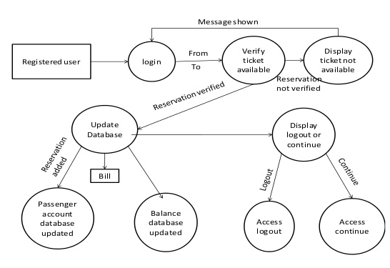

**Code:**

<?php if(!isset($Translation)){ @header('Location: index.php'); exit; } ?>

<?php include_once("{$currDir}/header.php"); ?>

<?php @include("{$currDir}/hooks/links-home.php"); ?>

<?php

/*

Classes of first and other blocks

---------------------------------

For possible classes, refer to the Bootstrap grid columns, panels and buttons documentation:

Grid columns: http://getbootstrap.com/css/#grid

Panels: http://getbootstrap.com/components/#panels

Buttons: http://getbootstrap.com/css/#buttons

*/

$block_classes = array(

'first' => array(

'grid_column' => 'col-sm-12 col-md-8 col-lg-6',

'panel' => 'panel-warning',

'link' => 'btn-warning'

),

'other' => array(

'grid_column' => 'col-sm-6 col-md-4 col-lg-3',

'panel' => 'panel-info',

'link' => 'btn-info'));?>

<style>

.panel-body-description{

margin-top: 10px;

height: 100px;

overflow: auto;

}

.panel-body .btn img{

margin: 0 10px;

max-height: 32px;

}

</style>

<?php

/* accessible tables */

$arrTables = get_tables_info();

if(is_array($arrTables) && count($arrTables)){

/* how many table groups do we have? */

$groups = get_table_groups();

$multiple_groups = (count($groups) > 1 ? true : false);

/* construct $tg: table list grouped by table group */

$tg = array();

if(count($groups)){

foreach($groups as $grp => $tables){

foreach($tables as $tn){

$tg[$tn] = $grp;

}}}

$i = 0; $current_group = '';

foreach($tg as $tn => $tgroup){

$tc = $arrTables[$tn];

/* is the current table filter-first? */

$tChkFF = array_search($tn, array());

/* hide current table in homepage? */

$tChkHL = array_search($tn, array());

/* allow homepage 'add new' for current table? */

$tChkAHAN = array_search($tn, array());

/* homepageShowCount for current table? */

$count_badge = '';

if($tc['homepageShowCount']){

$sql_from = get_sql_from($tn);

$count_records = ($sql_from ? sqlValue("select count(1) from " . $sql_from) : 0);

$count_badge = '<span class="badge hspacer-lg text-bold">' . number_format($count_records) . '</span>';

}

$t_perm = getTablePermissions($tn);

$can_insert = $t_perm['insert'];

$searchFirst = (($tChkFF !== false && $tChkFF !== null) ? '?Filter_x=1' : '');

?>

<?php if(!$i && !$multiple_groups){ /* no grouping, begin row */ ?>

<div class="row table_links">

<?php } ?>

<?php if($multiple_groups && $current_group != $tgroup){ /* grouping, begin group & row */ ?>

<?php if($current_group != ''){ /* not first group, so we should first end previous group */ ?>

</div><!-- /.table_links -->

<div class="row custom_links">

<?php

/* custom home links for current group, as defined in "hooks/links-home.php" */

echo get_home_links($homeLinks, $block_classes['other'], $current_group);

?>

</div>

</div><!-- /.collapse -->

<?php } ?>

<?php $current_group = $tgroup; ?>

<a class="btn btn-primary btn-block btn-lg collapser vspacer-lg" data-toggle="collapse" href="#group-<?php echo md5($tgroup); ?>"><?php echo $tgroup; ?> <i class="glyphicon glyphicon-chevron-right"></i></a>

<div class="collapse" id="group-<?php echo md5($tgroup); ?>">

<div class="row table_links">

<?php } ?>

<?php if($tChkHL === false || $tChkHL === null){ /* if table is not set as hidden in homepage */ ?>

<div id="<?php echo $tn; ?>-tile" class="<?php echo (!$i ? $block_classes['first']['grid_column'] : $block_classes['other']['grid_column']); ?>">

<div class="panel <?php echo (!$i ? $block_classes['first']['panel'] : $block_classes['other']['panel']); ?>">

<div class="panel-body">

<?php if($can_insert && $tChkAHAN !== false && $tChkAHAN !== null){ ?>

<div class="btn-group" style="width: 100%;">

<a style="width: 85%;" class="btn btn-lg <?php echo (!$i ? $block_classes['first']['link'] : $block_classes['other']['link']); ?>" title="<?php echo preg_replace("/&amp;(#[0-9]+|[a-z]+);/i", "&$1;", html_attr(strip_tags($tc['Description']))); ?>" href="<?php echo $tn; ?>_view.php<?php echo $searchFirst; ?>"><?php echo ($tc['tableIcon'] ? '<img src="' . $tc['tableIcon'] . '">' : '');?><strong class="table-caption"><?php echo $tc['Caption']; ?></strong><?php echo $count_badge; ?></a>

<a id="<?php echo $tn; ?>_add_new" style="width: 15%;" class="btn btn-add-new btn-lg <?php echo (!$i ? $block_classes['first']['link'] : $block_classes['other']['link']); ?>" title="<?php echo html_attr($Translation['Add New']); ?>" href="<?php echo $tn; ?>_view.php?addNew_x=1"><i style="vertical-align: bottom;" class="glyphicon glyphicon-plus"></i></a>

</div>

<?php }else{ ?>

<a class="btn btn-block btn-lg <?php echo (!$i ? $block_classes['first']['link'] : $block_classes['other']['link']); ?>" title="<?php echo preg_replace("/&amp;(#[0-9]+|[a-z]+);/i", "&$1;", html_attr(strip_tags($tc['Description']))); ?>" href="<?php echo $tn; ?>_view.php<?php echo $searchFirst; ?>"><?php echo ($tc['tableIcon'] ? '<img src="' . $tc['tableIcon'] . '">' : '');?><strong class="table-caption"><?php echo $tc['Caption']; ?></strong><?php echo $count_badge; ?></a>

<?php } ?>

<div class="panel-body-description"><?php echo $tc['Description']; ?></div>

</div>

</div>

</div>

<?php } ?>

<?php if($i == (count($arrTables) - 1) && !$multiple_groups){ /* no grouping, end row */ ?>

</div> <!-- /.table_links -->

<div class="row custom_links" id="custom_links">

<?php

/* custom home links, as defined in "hooks/links-home.php" */

echo get_home_links($homeLinks, $block_classes['other'], '*');?>

</div>

<?php } ?>

<?php if($i == (count($arrTables) - 1) && $multiple_groups){ /* grouping, end last group & row */ ?>

</div> <!-- /.table_links -->

<div class="row custom_links" id="custom_links">

<?php

/* custom home links for last table group, as defined in "hooks/links-home.php" */

echo get_home_links($homeLinks, $block_classes['other'], $tgroup);

/* custom home links having no table groups, as defined in "hooks/links-home.php" */

echo get_home_links($homeLinks, $block_classes['other']);

?>

</div>

</div><!-- /.collapse -->

<?php } ?>

<?php

$i++;

}

}else{

?><script>window.location='index.php?signIn=1';</script><?php

}

?>

<script>

$j(function(){

var table_descriptions_exist = false;

$j('div[id$="-tile"] .panel-body-description').each(function(){

if($j.trim($j(this).html()).length) table_descriptions_exist = true;});

if(!table_descriptions_exist){

$j('div[id$="-tile"] .panel-body-description').css({height: 'auto'});

}

$j('.panel-body .btn').height(32);

$j('.btn-add-new').click(function(){

var tn = $j(this).attr('id').replace(/_add_new$/, '');

modal_window({

url: tn + '_view.php?addNew_x=1&Embedded=1',

size: 'full',

title: $j(this).prev().children('.table-caption').text() + ": <?php echo html_attr($Translation['Add New']); ?>"

});

return false;

});

/* adjust arrow directions on opening/closing groups, and initially open first group */

$j('.collapser').click(function(){

$j(this).children('.glyphicon').toggleClass('glyphicon-chevron-right glyphicon-chevron-down');

});

/* hide empty table groups */

$j('.collapser').each(function(){

var target = $j(this).attr('href');

if(!$j(target + " .row div").length) $j(this).hide();});

$j('.collapser:visible').eq(0).click();});</script><?php include_once("$currDir/footer.php"); ?>

# OUTPUT:

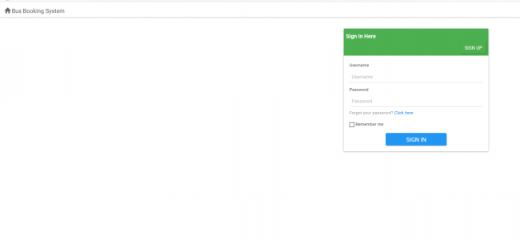

**LOGIN PAGE**

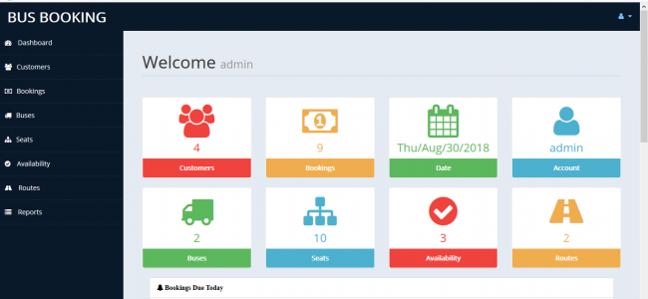

**ADMIN HOME PAGE**

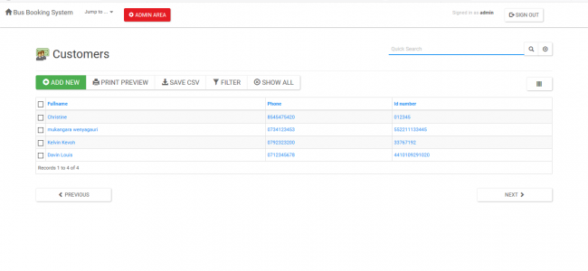

**CUSTOMER INFO PAGE**

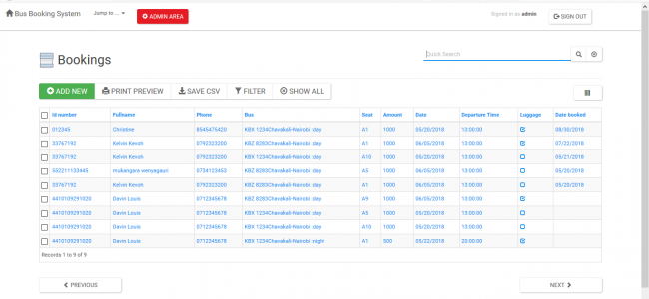

**BOOKINGS PAGE**

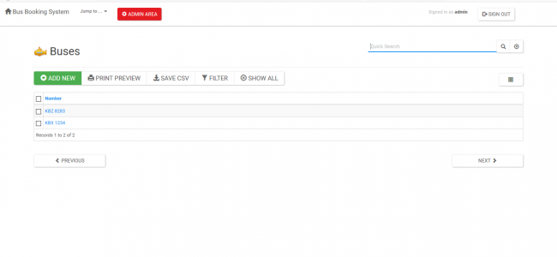

**BUSES INFO PAGE**

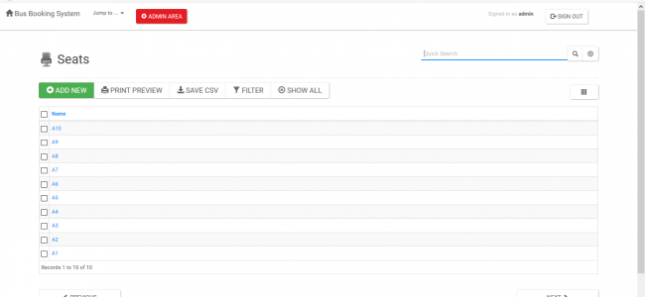

**SEATS INFO PAGE**

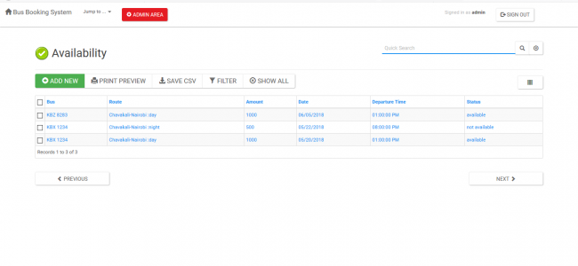

**AVAILABILITY INFO PAGE**

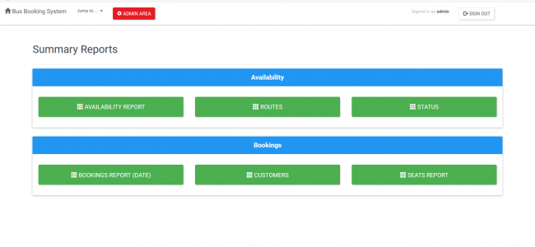

**SUMMARY REPORTS PAGE**

**Conclusion:**

Finally, in Online Bus Booking System, we have developed a secure, user-friendly Bus Booking System. This Project basically provides Bus information and regarding bus information. First of all, in our website any user or visitors view our system and search the bus and how many seats are available in our buses.

The user can also register its own seats in the bus this website. The user can post a comment on different Bus Services. But user can compulsory registered first in the system. Search Bus category wise. This system has automated process to alert employee as well as customers who have booked their seats with the system.

To access this system you only need a web browser, internet connection. This is the 24X7 available systems.  We observed the working of the Bus booking system and after going through it, we get to know that there are many operations, which they have to do manually.

By using this website, we can reserve tickets, through telephone lines, via the internet. The customer can check the availability of bus and reserve selective seats. The project provides and reviews all sorts of constraints so that user does give only user data and thus validation is done in an efficient manner.

**References:**

* https://code-projects.org/bus-booking-system-in-php-with-source-code/
* https://www.scribd.com/document/346551269/35883362-Online-Bus-Reservation-a-Project-Report-1